Data flow of MVVM architecture:
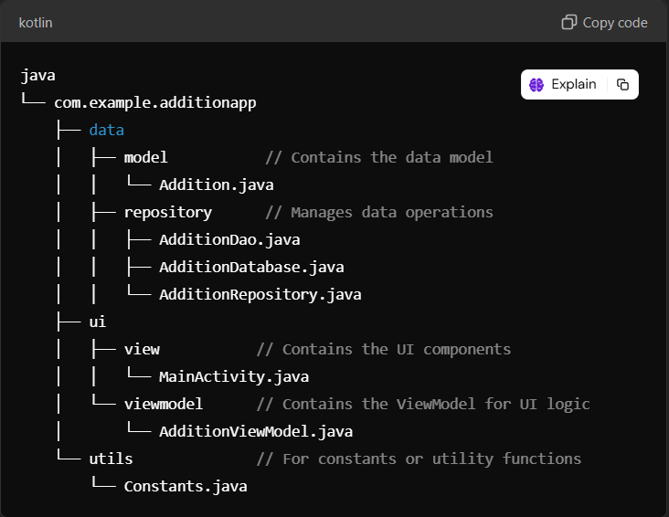

Explanation:
The provided code structure represents a typical layout for an Android application named "AdditionApp" that performs addition operations. Here’s a concise explanation of each part of the structure:

1. Package Directory (`com.example.additionapp`):
- This is the root package for the application, following standard Java package naming conventions.

2. Data Layer (`data`):
- This part of the application manages data-related functionalities.
- Model (`model`):
- Contains the data model class.
- **Addition.java**: This class likely defines the properties and behaviors of the addition operation, such as operands and the result.
- **Repository (`repository`)**:
- Responsible for handling data operations, possibly from local storage or remote sources.
- **AdditionDao.java**: This Data Access Object (DAO) interface might define methods for database operations related to additions.
- **AdditionDatabase.java**: This class probably manages the database setup and configuration.
- **AdditionRepository.java**: This class acts as a mediator between the data sources (like databases) and the rest of the app, abstracting data operations.

3. UI Layer (`ui`):
- This section contains components related to the user interface.
- **View (`view`)**:
- Contains the main user interface components.
- **MainActivity.java**: The entry point of the app, where the user interface is initialized and displayed.
- **ViewModel (`viewmodel`)**:
- Holds UI-related data in a lifecycle-conscious way.
- **AdditionViewModel.java**: This class likely contains the business logic for handling data operations and communicates between the UI and the repository.

4. **Utilities (`utils`)**:
- This folder is for defining constants or utility functions that can be reused throughout the application.
- **Constants.java**: Contains constant values used across the app, promoting maintainability and preventing the use of magic numbers or strings.

Overall, this code structure follows the Model-View-ViewModel (MVVM) architectural pattern, promoting separation of concerns, making the app easier to manage and scale.

Dependencies for adding MVVM:
dependencies {
implementation(libs.appcompat)
implementation(libs.material)
implementation(libs.activity)
implementation(libs.constraintlayout)
testImplementation(libs.junit)
androidTestImplementation(libs.ext.junit)
androidTestImplementation(libs.espresso.core)

// ViewModel and LiveData
implementation("androidx.lifecycle:lifecycle-viewmodel:2.6.1")
implementation("androidx.lifecycle:lifecycle-livedata:2.6.1")

// Room (for database)
implementation("androidx.room:room-runtime:2.6.0")
annotationProcessor("androidx.room:room-compiler:2.6.0")

// Coroutine support (optional for later)
implementation("org.jetbrains.kotlinx:kotlinx-coroutines-core:1.6.4")
implementation("org.jetbrains.kotlinx:kotlinx-coroutines-android:1.6.4")
}

